Task1:

Code:

include irvine32.inc

.data

arr1 dword 4 dup(?)

msg1 byte "Enter 4 numbrs : ",0

msg2 byte "numbers are not equal ",0

msg3 byte "numbers are equal ",0

.code

main proc

mov edx, offset msg1

call writestring

call crlf

mov ecx,4

mov esi , offset arr1

input:

call readint

add esi,4

loop input

mov ecx,3

mov esi, offset arr1

compare:

mov eax,[esi]

add esi,4

cmp eax,[esi]

jne notEqual

loop compare

mov edx ,offset msg3

call writestring

call crlf

exit

notEqual:

mov edx ,offset msg2

call writestring

call crlf

exit

main endp

end main

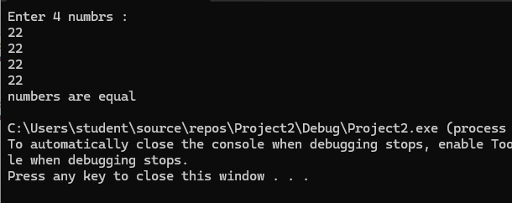

Task 2:

Code:

include irvine32.inc

.data

arr Sword 0,0,0,-150,120,35,-12,66,4,0

msg1 byte "no non zero number in array ",0

msg2 byte "non zero number in array is : ",0

.code

main proc

mov ecx,10

mov esi, offset arr

compare:

movsx eax,word ptr [esi]

cmp eax,0

jnz jump

add esi,2

loop compare

mov edx , offset msg1

call writestring

call crlf

exit

jump:

mov edx,offset msg2

call writestring

call writeint

exit

main endp

end main

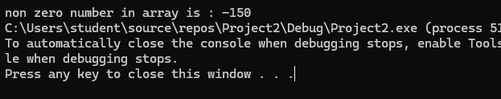

Qno3

Code: INCLUDE Irvine32.inc

.data

var DWORD 5

edx_val DWORD ?

ecx_val DWORD 7

x DWORD ?

.code

main PROC

mov eax, var

mov edx, eax

inc edx

mov ecx, ecx_val

mov ebx, 0

cmp eax, ecx

jge ELSE_PART

cmp ecx, edx

jl ELSE_PART

mov ebx, 0

jmp END_IF

ELSE_PART:

mov ebx, 1

END_IF:

mov x, ebx

mov eax, x

call WriteInt

call Crlf

exit

main ENDP

END main

Qno4

Code:

INCLUDE Irvine32.inc

.data

var DWORD 0

hello BYTE "Hello",0

world BYTE "World",0

.code

main PROC

mov eax, var

WHILE_LOOP:

cmp eax, 10

jg END_WHILE

cmp eax, 5

jl PRINT_HELLO

jmp PRINT_WORLD

PRINT_HELLO:

mov edx, OFFSET hello

call WriteString

call Crlf

jmp INCREMENT

PRINT_WORLD:

mov edx, OFFSET world

call WriteString

call Crlf

INCREMENT:

inc eax

jmp WHILE_LOOP

END_WHILE:

exit

main ENDP

END main

Qno 5

Code:

INCLUDE Irvine32.inc

.data

arr WORD 10, 4, 7, 14, 299, 156, 3, 19, 29, 300, 20

arrSize DWORD 11

promptMsg BYTE "Enter number: ", 0

foundMsg BYTE "Found at index: ", 0

notFoundMsg BYTE "Not found", 0

searchValue WORD ?

.code

main PROC

mov edx, OFFSET promptMsg

call WriteString

call ReadInt

mov searchValue, ax

mov ecx, arrSize

mov esi, OFFSET arr

mov edi, 0

searchLoop:

mov ax, [esi]

cmp ax, searchValue

je found

add esi, 2

inc edi

loop searchLoop

mov edx, OFFSET notFoundMsg

call WriteString

call Crlf

jmp endProgram

found:

mov edx, OFFSET foundMsg

call WriteString

mov eax, edi

call WriteDec

call Crlf

endProgram:

exit

main ENDP

END main  
Output:

Qno 6

Code:

INCLUDE Irvine32.inc

.data

arr WORD 10, 4, 7, 14, 299, 156, 3, 19, 29, 300, 20

arrSize DWORD 11

beforeMsg BYTE "Array before sorting: ", 0

afterMsg BYTE "Array after sorting: ", 0

space BYTE " ", 0

.code

main PROC

mov edx, OFFSET beforeMsg

call WriteString

call Crlf

call DisplayArray

call BubbleSort

mov edx, OFFSET afterMsg

call WriteString

call Crlf

call DisplayArray

exit

main ENDP

BubbleSort PROC

mov ecx, arrSize

dec ecx

outerLoop:

push ecx

mov esi, OFFSET arr

innerLoop:

mov ax, [esi]

cmp ax, [esi+2]

jle noSwap

xchg ax, [esi+2]

mov [esi], ax

noSwap:

add esi, 2

loop innerLoop

pop ecx

loop outerLoop

ret

BubbleSort ENDP

DisplayArray PROC

mov ecx, arrSize

mov esi, OFFSET arr

printLoop:

movzx eax, WORD PTR [esi]

call WriteDec

mov edx, OFFSET space

call WriteString

add esi, 2

loop printLoop

call Crlf

ret

DisplayArray ENDP

END main  
Output:

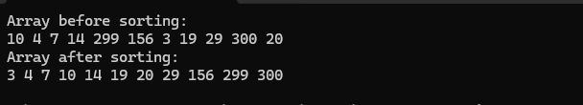

Qno 7

Code:

INCLUDE Irvine32.inc

.data

promptMsg BYTE "Enter a number (1-7): ", 0

invalidMsg BYTE "Invalid input! Enter number between 1 and 7", 0

monday BYTE "Monday", 0

tuesday BYTE "Tuesday", 0

wednesday BYTE "Wednesday", 0

thursday BYTE "Thursday", 0

friday BYTE "Friday", 0

saturday BYTE "Saturday", 0

sunday BYTE "Sunday", 0

dayTable DWORD OFFSET monday, OFFSET tuesday, OFFSET wednesday

DWORD OFFSET thursday, OFFSET friday, OFFSET saturday, OFFSET sunday

userInput DWORD ?

.code

main PROC

mov edx, OFFSET promptMsg

call WriteString

call ReadInt

mov userInput, eax

cmp eax, 1

jl invalid

cmp eax, 7

jg invalid

dec eax

mov esi, OFFSET dayTable

mov edx, [esi + eax*4]

call WriteString

call Crlf

jmp endProgram

invalid:

mov edx, OFFSET invalidMsg

call WriteString

call Crlf

endProgram:

exit

main ENDP

END main

Qno 8:

Code:

INCLUDE Irvine32.inc

.data

promptMsg BYTE "Enter a character: ", 0

alphabetMsg BYTE "It is an alphabet", 0

notAlphabetMsg BYTE "It is not an alphabet", 0

userChar BYTE ?

.code

main PROC

mov edx, OFFSET promptMsg

call WriteString

call ReadChar

mov userChar, al

call WriteChar

call Crlf

cmp al, 'A'

jl notAlphabet

cmp al, 'Z'

jle isAlphabet

cmp al, 'a'

jl notAlphabet

cmp al, 'z'

jle isAlphabet

notAlphabet:

mov edx, OFFSET notAlphabetMsg

call WriteString

call Crlf

jmp endProgram

isAlphabet:

mov edx, OFFSET alphabetMsg

call WriteString

call Crlf

endProgram:

exit

main ENDP

END main

Output:

